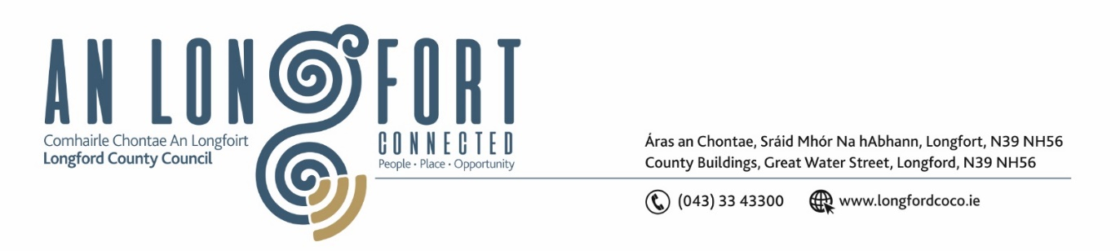

**GRANARD MUNICIPAL DISTRICT**

**Minutes of Meeting of Granard Municipal District held in Granard Library**

**on Tuesday, 22 November 2022 at 3.30pm**

**CATHAOIRLEACH**: Councillor Colin Dalton

**MEMBERS PRESENT**: Councillors – PJ Reilly, Paraic Brady and

Turlough McGovern

**IN ATTENDANCE**: Ms. Barbara Heslin, Director of Services

Ms. Linda Higgins, Administrative Officer

Mr. David Coppinger, Senior Executive Engineer

**APOLOGIES** Councillor Garry Murtagh

**MEETINGS**

**ADMINISTRATOR**: Ms Ann Marie McKeon

**ADOPTION OF MINUTES – circulated**

On the proposal of Councillor Turlough Mc Govern seconded by Councillor Colin Dalton, it was unanimously agreed to adopt the Minutes of Granard Municipal District Meeting held on the 27 September 2022.

On the proposal of Councillor Turlough Mc Govern seconded by Councillor Colin Dalton, it was unanimously agreed to adopt the Minutes of Granard Municipal District Committee Meeting held on the 27 September 2022.

**MATTERS ARISING FROM MINUTES**

The elected members recognised the Civic Recognition which was held before the meeting and congratulated Aoibhinn Ni Loinsigh on receiving her Recognition Award for the All-Ireland Under-18 Button Accordion and they acknowledged Councillor PJ Reilly for submitting the notice of motion.

**DECLARATION OF INTEREST BY MEMBERS**

None.

**MANAGEMENT REPORT INCORPORATING AREA ENGINEER’S PROGRESS**

**REPORT – circulated**

Barbara Heslin updated the members on the following –

* Social Housing
* Housing Capital Programme 2022
* Longford Tourism
* Outdoor Recreation Infrastructure Scheme
* Library Services
* Heritage
* Regeneration

David Coppinger detailed the Area Engineer’s Progress Report –

* Roadworks
* Local Improvement Schemes
* Community Involvement Scheme.
* Drainage
* Climate Action Funding
* Car Park behind Granard Garda Station

David and Barbara replied to queries raised on the following issues –

* Safety Schemes
* Drumlish Graveyard
* Active Travel
* Trails
* Moate, Granard

**CONSIDERATION OF PART VIII NO 99 –** **ENNYBEGS CYCLIST AND PEDESTRIAN IMPROVEMENT SCHEME. REPORT IN ACCORDANCE WITH SECTION 179 OF THE PLANNING AND DEVELOPMENT ACT 2000 (AS AMENDED) AND PART 8 OF THE PLANNING & DEVELOPMENT REGULATIONS 2001 (AS AMENDED) – circulated.**

On the proposal of Councillor Paraic Brady and seconded by Councillor Turlough Mc Govern it was unanimously agreed to adopt the Part VIII, No 99 – Ennybegs cyclist and pedestrian improvement scheme. Report in accordance with Section 179 of the Planning and Development Act 2000 (as amended) and Part 8 of the Planning & Development Regulations 2001 (as amended) as circulated.

**CONSIDERATION OF PART VIII NO 96 -** **CAR PARK AT GRANARD, COUNTY LONGFORD. REPORT IN ACCORDANCE WITH SECTION 179 OF THE PLANNING AND DEVELOPMENT ACT 2000 (AS AMENDED) AND PART 8 OF THE PLANNING & DEVELOPMENT REGULATIONS 2001 (AS AMENDED) – circulated.**

On the proposal of Councillor Turlough Mc Govern and seconded by Councillor PJ Reilly it was unanimously agreed to adopt the Part VIII, No 96 – car park at Granard, County Longford. Report in accordance with Section 179 of the Planning and Development Act 2000 (as amended) and Part 8 of the Planning & Development Regulations 2001 (as amended) as circulated.

**NOTICE OF MOTIONS**

**Pedestrian Crossing Mill Road**

The following Notice of Motion was proposed by Councillor Paraic Brady and seconded by Councillor Turlough Mc Govern:

“I call on Longford County Council to provide clarity about raised pedestrian crossing

in Drumlish from playground on the Mill Road.”

**Response**

Currently there are no specific works programmed to provide a pedestrian crossing at this location. A few years ago, there was some discussion on the matter, but nothing was specifically agreed. There is no funding available currently for such a scheme.

In the last few years there have been various requests for pedestrian crossing facilities in at least three locations in the village, we will ask the Road Design section to carry out a review of pedestrian crossing requirements in Drumlish to see what if any crossings are warranted.

**Road Markings**

The following Notice of Motion was proposed by Councillor Colin Dalton and seconded by Councillor Turlough Mc Govern:

“I call on Longford County Council to consider road markings from Ballinalee to Aughnacliffe and to also refresh road markings from Esker Cross to Doherty’s Cross.”

**Response**

Granard Municipal District employees will examine these two locations and assess what might be needed and possible, given the tight budget situation.

Councillor Colin Dalton wished all present a very Happy Christmas and encouraged people to shop local this Christmas and Colin thanked the Executive for their support during 2022.

This concluded the business of the meeting.

**Signed: ____________________**

**Ann Marie McKeon**

**Meetings Administrator.**

**Confirmed and adopted at Granard Municipal District Meeting held on the**

**24 January 2023.**

**Signed: _______________**

**Cathaoirleach.**